**[Dozierforsenate](https://wapdc.freshdesk.com/a/contacts/13042598980)**

 reported via email

To:"PDC Support" <pdc@pdc.wa.gov>

I am unaware of any signs that were distributed without a political affiliation. All the signs printed had a “R” and were designed and printed by a professional company that handles political signs on a regular basis.  
  
If you need further proof or information, I am happy to release the name of the company.  
  
Best,  
  
Perry Dozier

In response I have attached the sign that was forwarded to me from Integrity Design.  If I am reading the RCW correctly this sign fall within the recommendations.

The largest letters are 4.65” and the (R) is .85”, if you divide 4.65”x10 it is .465”, so from what I understand .465 is 10% of 4.65”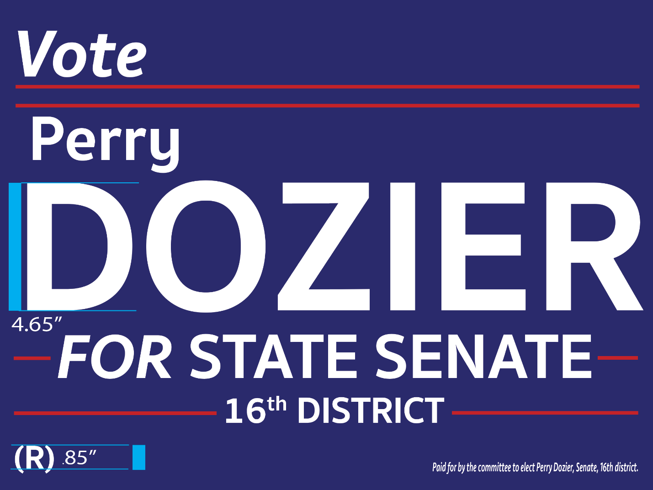

Best,

Perry Dozier

Sent from my iPad